# 

# **Department of Computer Science and Engineering Islamic University of Technology (IUT)** A subsidiary organ of OIC

# **Laboratory Report**

# CSE 4412: Data Communication and Networking Lab

## 

## **Name: Namisa Najah Raisa Student ID: 210042112 Section: B(Even) Semester: 4th Academic Year: 2022-23**

**Date of Submission: 25th February, 2024**

### **Title:** Configuring and Verifying of RIP and OSPF in a network topology.

### **Objective**:

1. Describe the concept of dynamic routing

2. Explain disadvantages of RIPv1 and improvement in RIPv2

3. Configure Routing Information Protocol (RIP) in a network topology following given specifications

4. Describe the concept of OSPF and related terminologies

5. Explain the advantages of OSPF over RIP

6. Configure OSPF in a network topology following the given specifications

**Devices/ software Used**:

* + - 1. Cisco Packet Tracer

### **Theory:**

*(Explain in brief the listed keywords)*

**Routing Information Protocol (RIP):**

1. **Distance-Vector:** RIP is a distance-vector routing protocol, which means routers exchange routing information based on the distance (number of hops) and direction (vector) to reach a destination network.
2. **Routing Metric:** RIP uses the number of hops (intermediate routers) as its metric for path selection. It assumes the shortest path is the one with the fewest hops. RIP has a maximum hop count of 15. If a route exceeds this limit, it is considered unreachable.
3. **Algorithm:** RIP utilizes the Bellman-Ford algorithm to determine the best path to a destination. Routers periodically share their routing tables with neighboring routers.
4. **Routing Table Updates:** RIP routers exchange routing information with their neighbors at regular intervals (typically every 30 seconds), broadcasting their entire routing table.
5. **Convergence Time:** RIP's convergence time can be slow, especially in large networks. The network experiences temporary routing inconsistencies during the convergence process.
6. **Version:** RIP has two versions - RIPv1 and RIPv2. RIPv2 includes improvements such as support for Variable Length Subnet Masking (VLSM) and better security features.
7. **Use Cases:** RIP is suitable for small to medium-sized networks where simplicity is valued over advanced features. It's commonly used in educational institutions and smaller organizations.

**Forwarding Table used in RIP:**

RIP routers utilize a forwarding table for routing decisions. This table includes entries for destination networks, next-hop IP addresses, and metrics based on hop count. The route type indicates if a route is directly connected, static, or learned through RIP updates. Split horizon prevents routers from advertising routes back out of the interface they were received. Route aging, hold-down timers, and garbage collection maintain the table's integrity. RIP's simplicity is reflected in its straightforward metric and periodic updates. While effective in small to medium-sized networks, RIP's limitations include slower convergence and scalability challenges.

**Hop Count as cost:**

In networking, hop count refers to the number of routers or network devices a packet must traverse to reach its destination. The concept of hop count serves as a cost metric in distance-vector routing protocols like RIP (Routing Information Protocol). In RIP, routes are chosen based on the lowest hop count, considering paths with fewer intermediate devices as more favorable. Each router along the path increments the hop count. RIP routers exchange this information, and the shortest path, with the least hop count, is chosen for forwarding packets. While hop count is a simple and intuitive metric, it may not accurately reflect the actual speed or quality of a network link. RIP's maximum hop count limit is 15, and routes exceeding this limit are considered unreachable.

**Timers in RIP:**

In RIP, timers play a crucial role in managing routing information and ensuring network stability. The update timer, typically set to 30 seconds, determines how often routers exchange routing information. The invalid timer, set to three times the update timer, marks a route as invalid if no updates are received within this period. The holddown timer, initiated after an update indicating a route is unreachable, prevents the router from accepting new information about that route for a specified duration, usually three times the update timer. These timers collectively contribute to RIP's convergence process by regulating when routers share information, detect invalid routes, and stabilize the routing tables. Properly configured timers are essential for maintaining accurate and timely routing information in RIP-based networks.

### 

### **Diagram of the experiment:**

*(Provide screenshot of the final network topology. Make sure to label the network components.)*

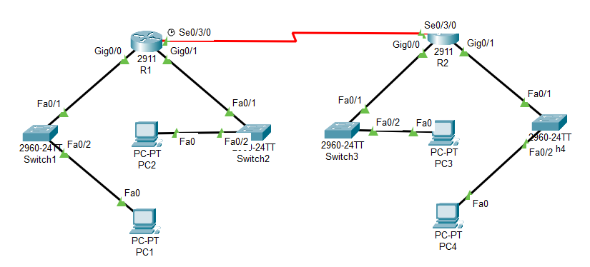**Task #01:**

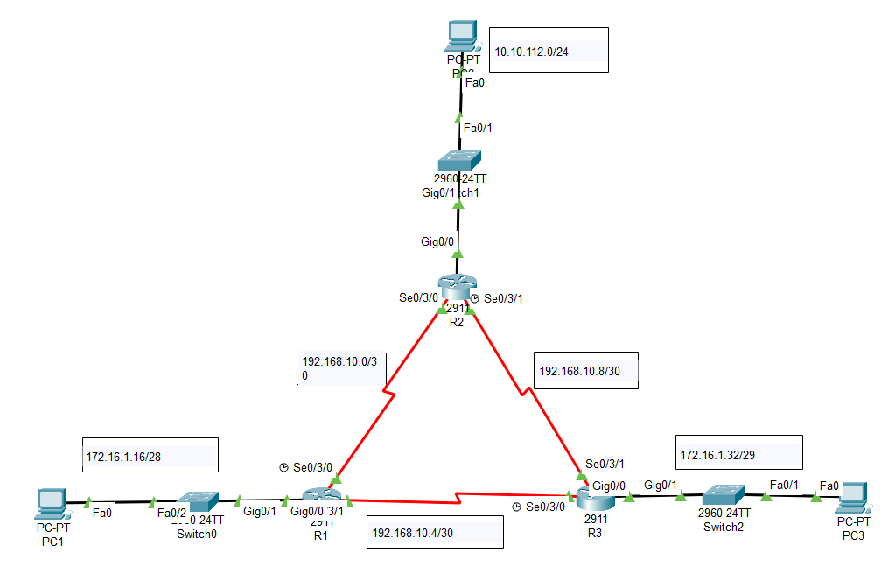

**Task #02:**

### **Working Procedure:**

***(****Explain in brief how you completed the tasks. Provide necessary screenshots of used commands for each task.)*

**Task #01:**

**Configure R1 interfaces:**

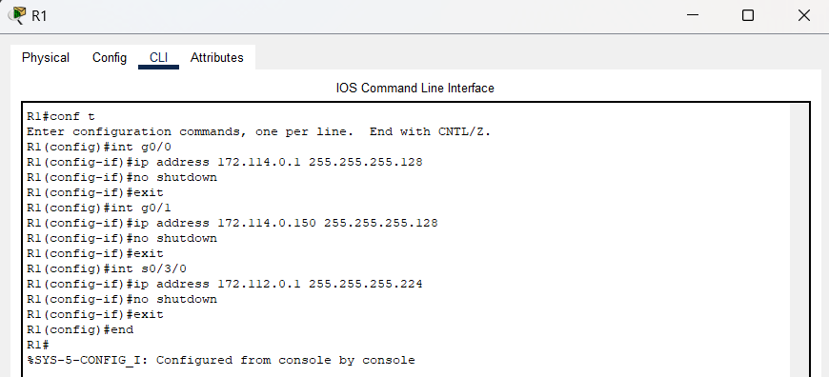

**Configure R2 interfaces:**

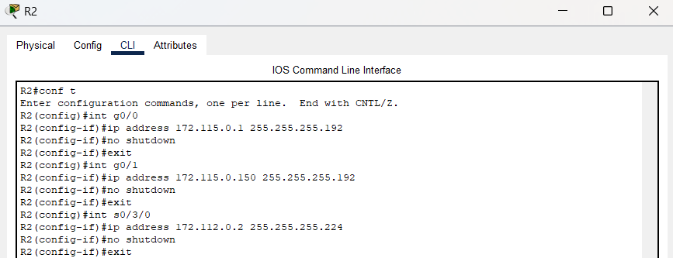

**Configure PC1:**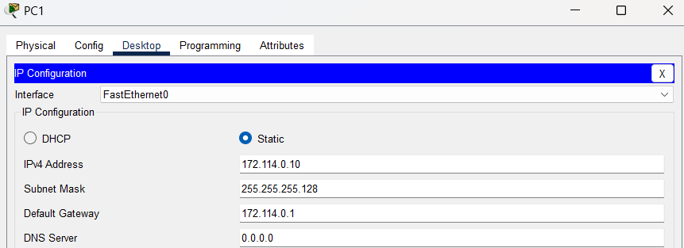

**Configure PC2:**

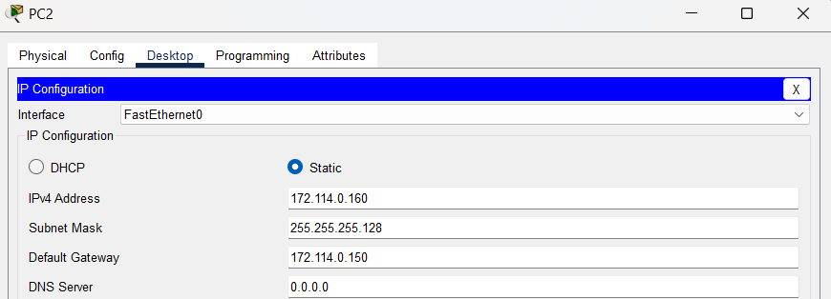

**Configure PC3:**

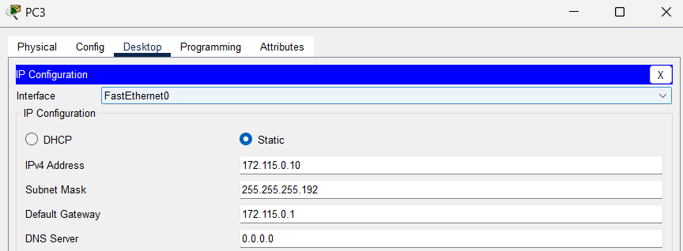

**Configure PC4:**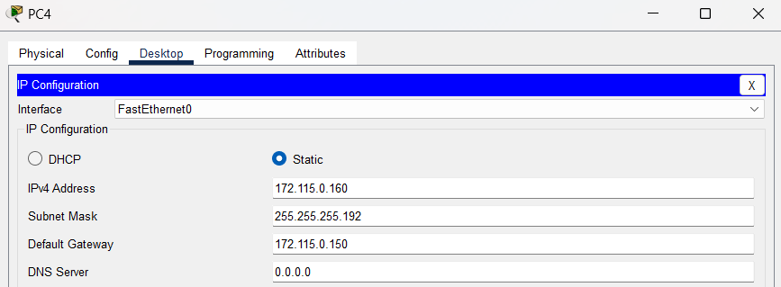

**Configure RIP in R1:**

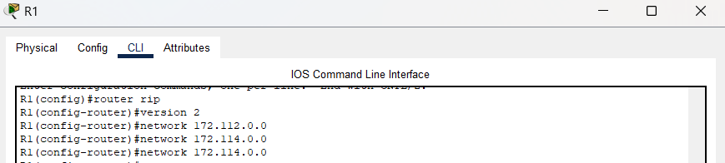

**Configure RIP in R2:**

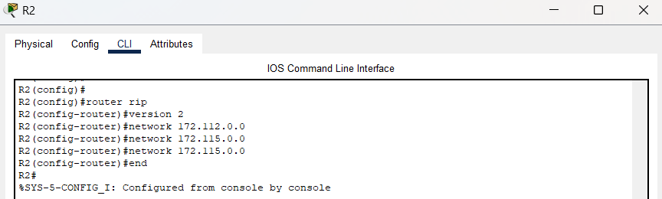

**Verify:**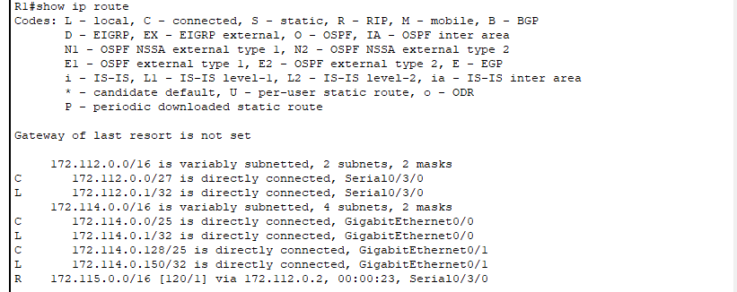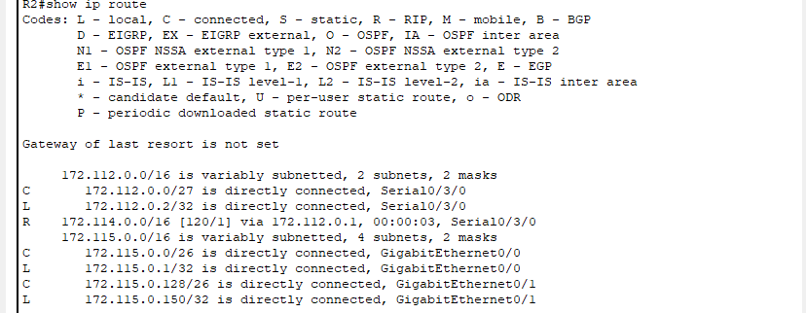

**Pinging from PCs:**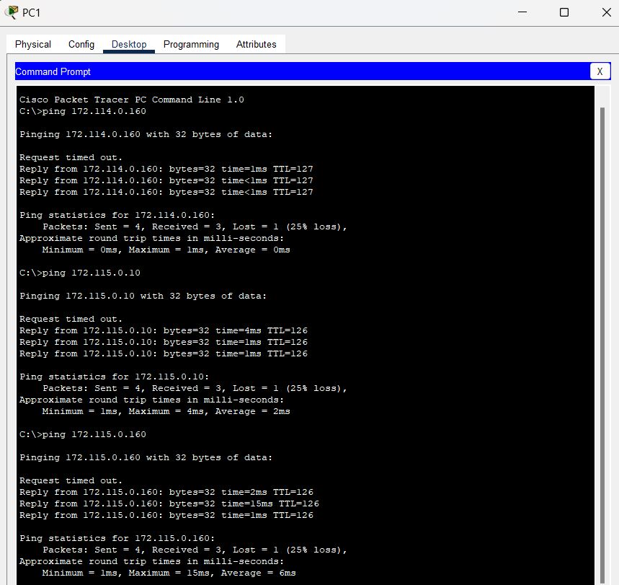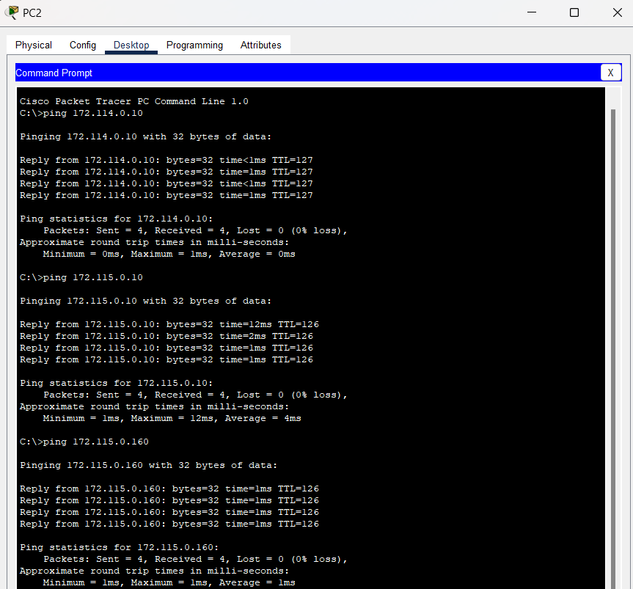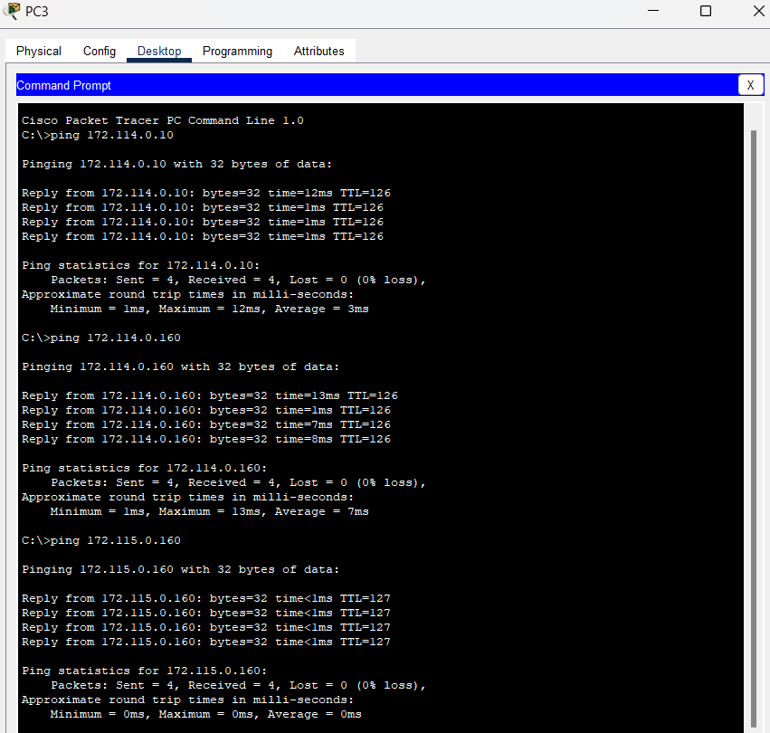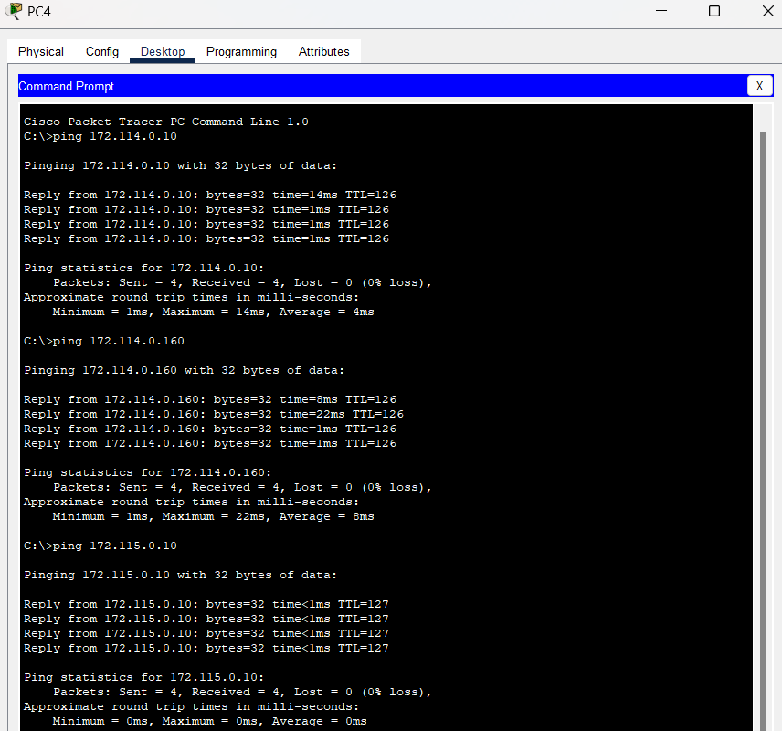

**Task #02:**

**Configure the routers:**

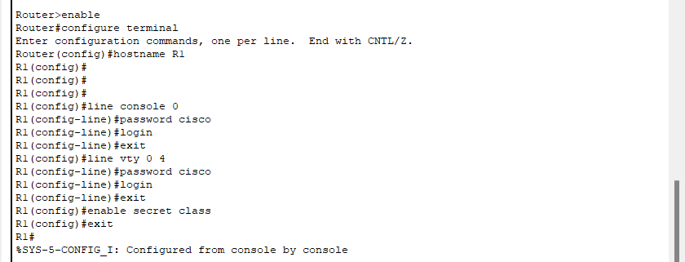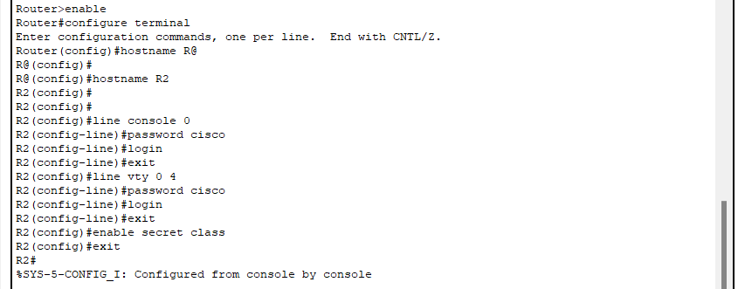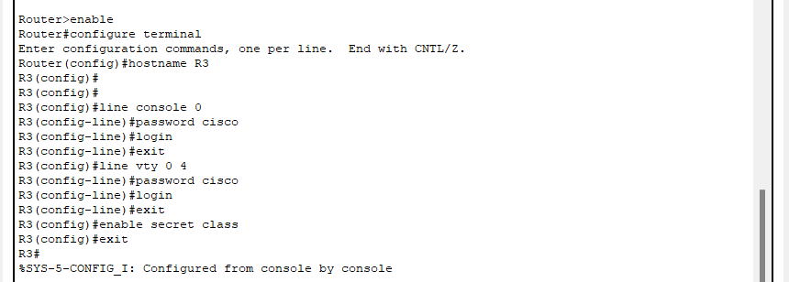

**Disable DNS lookup:**



**Configure the interfaces in R1,R2,R3:**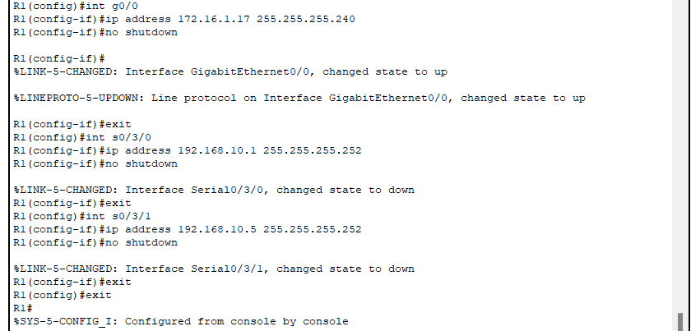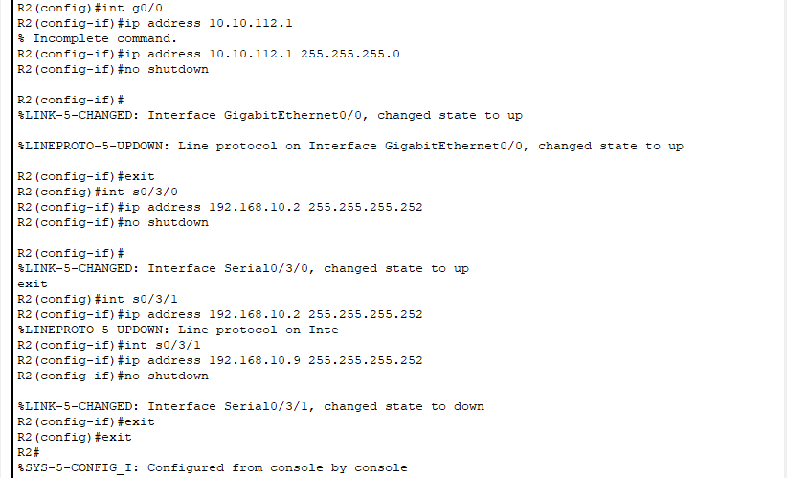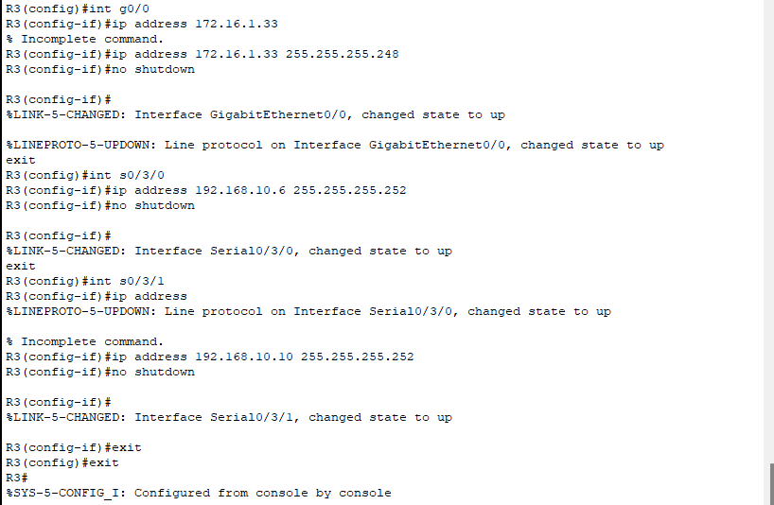

**Verify IP addressing and interfaces:**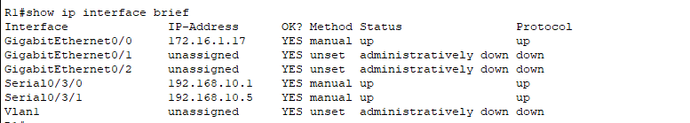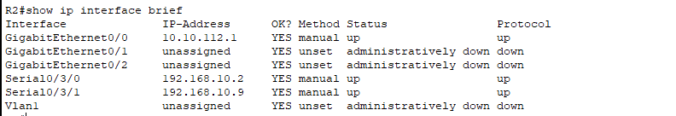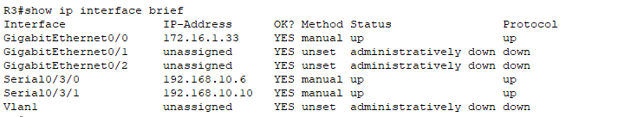

**Configure ethernet interfaces of PC1,PC2,PC3:**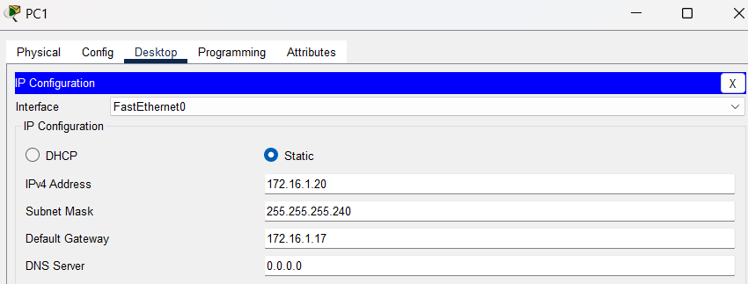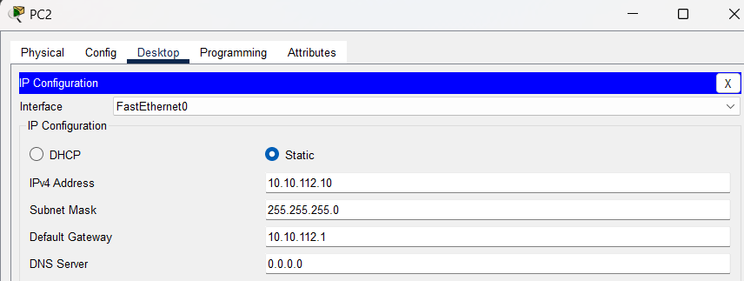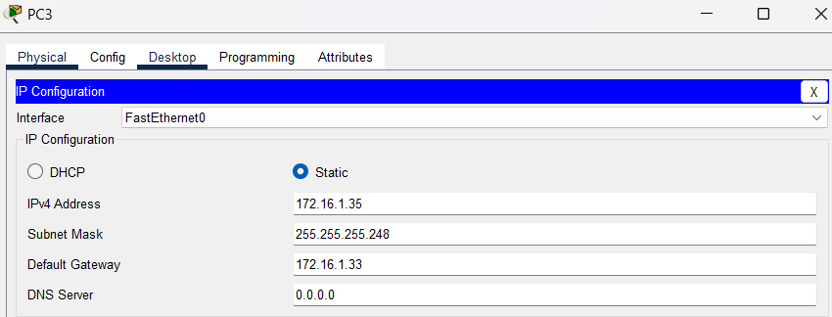

**Configure OSPF on the R1,R2,R3 Router:**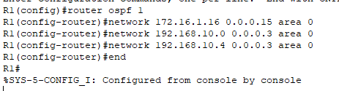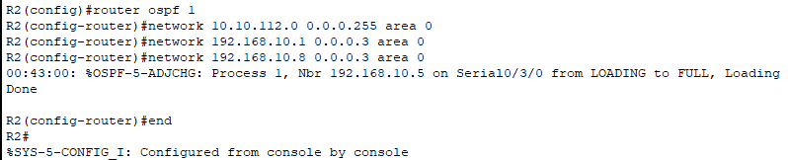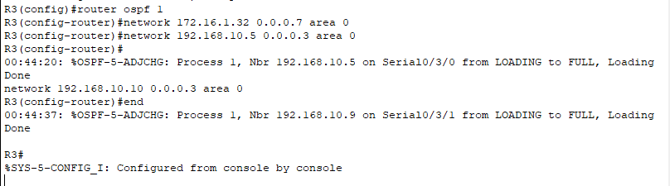

**Configure OSPF router IDs:**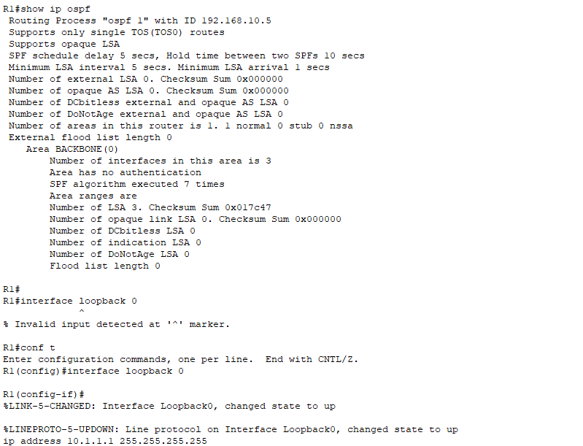

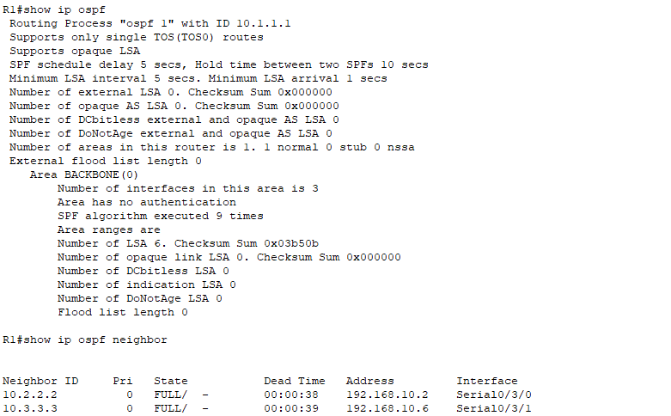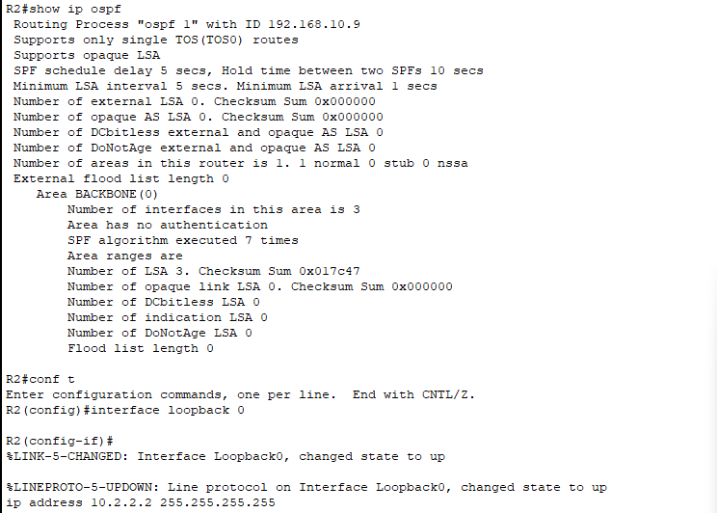

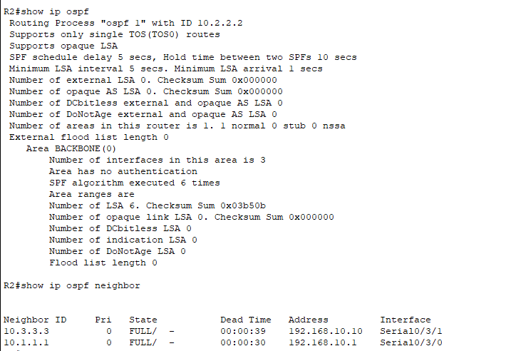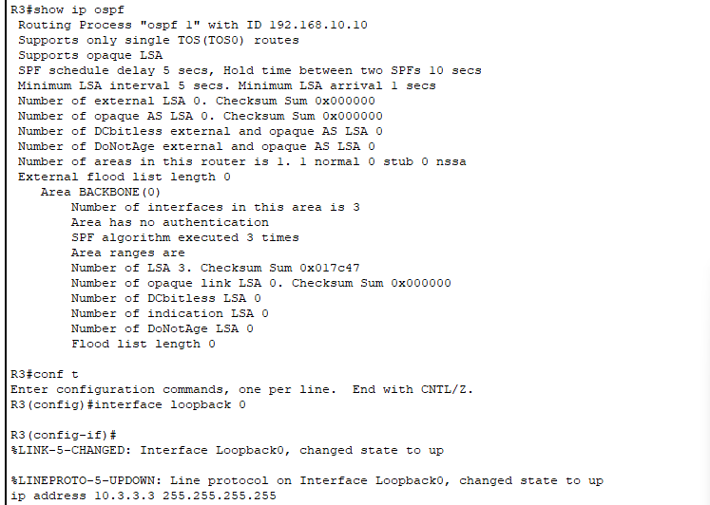

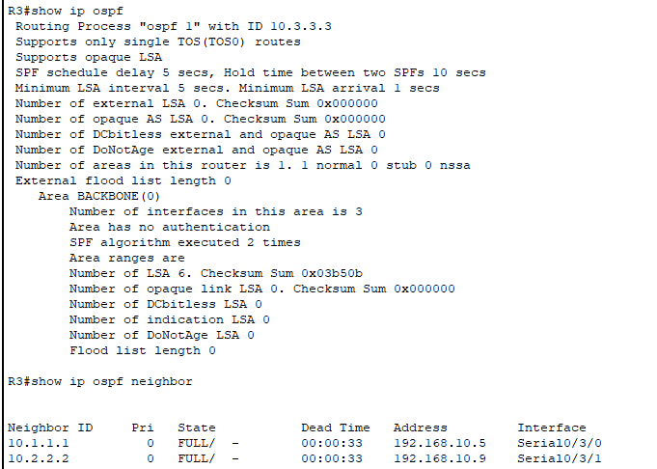

Step 5: Use the router-id command to change the router ID on the R1 router:

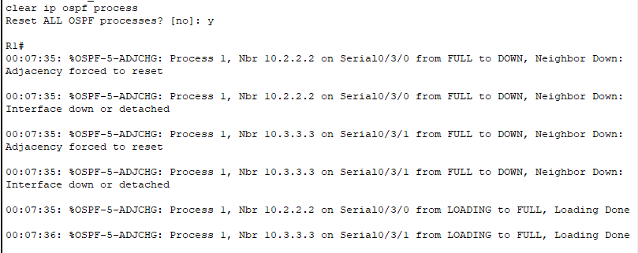

Step 6: Use the show ip ospf neighbor command on router R2 to verify that the router ID of R1 has been changed:

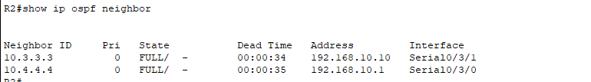

**Verify OSPF operation:**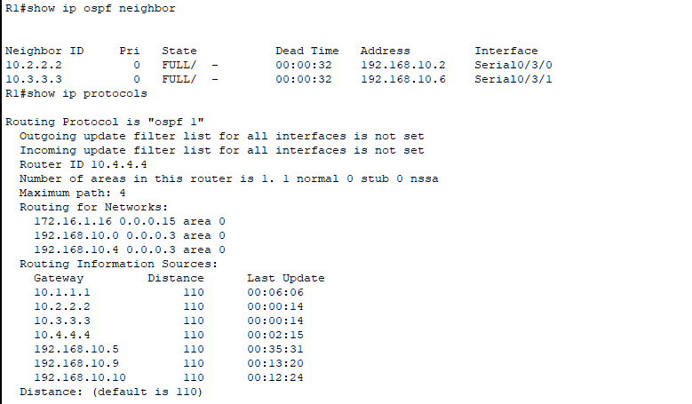

**Examine OSPF routes in the routing tables:**

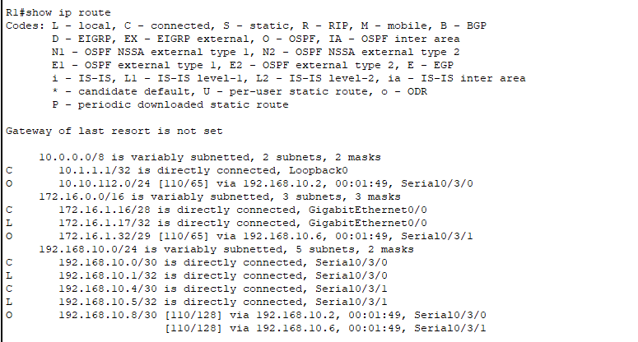

**Configure OSPF cost:**

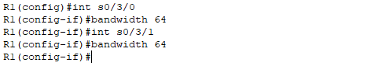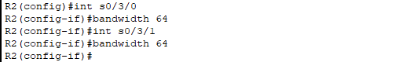

Use the show ip ospf interface command on the R1 router to verify the cost of the serial links:

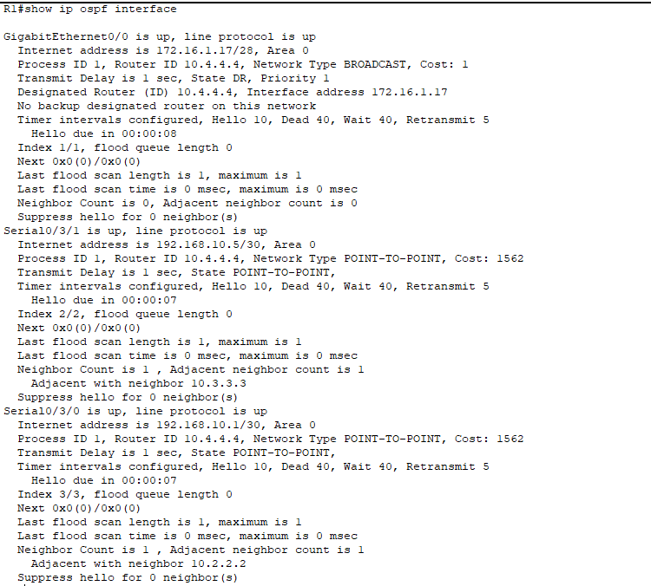



**For R3:**

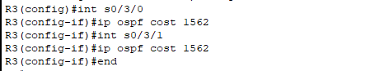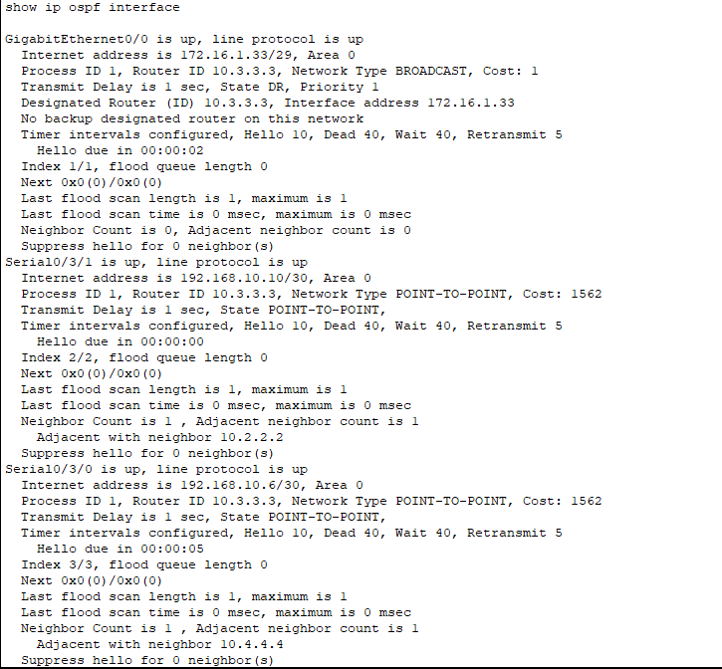



**Redistribute an OSPF default route:**

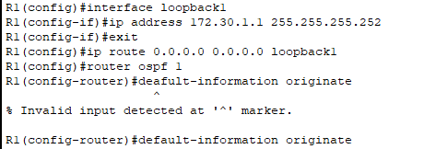

**Configure additional OSPF features:**



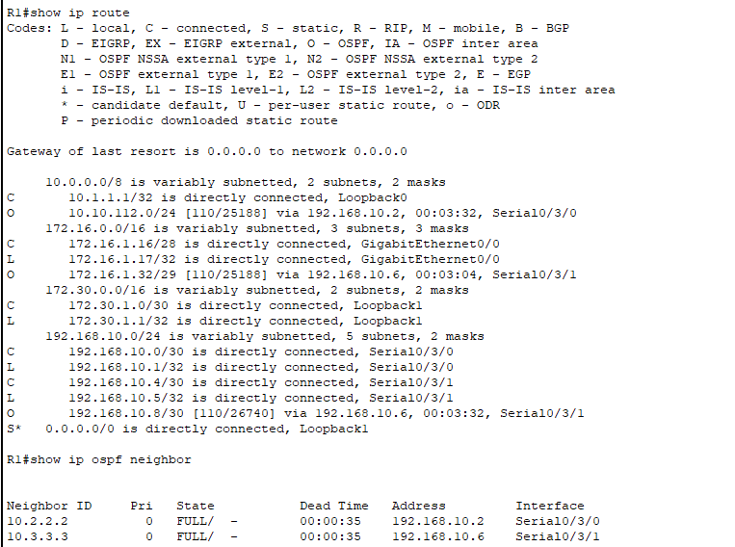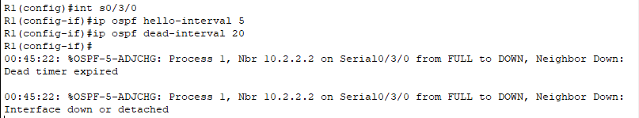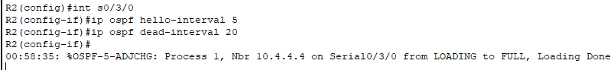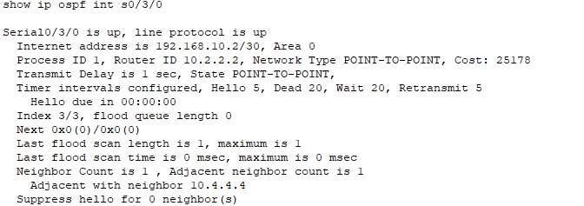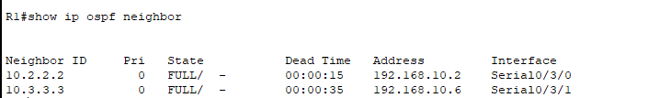

**Ping from PCs:**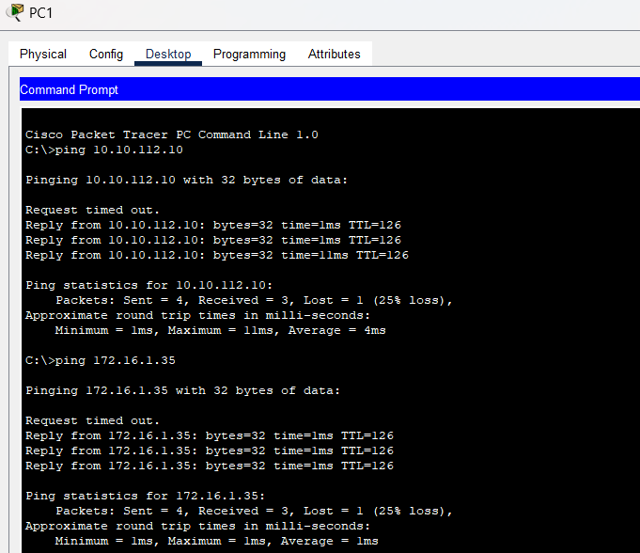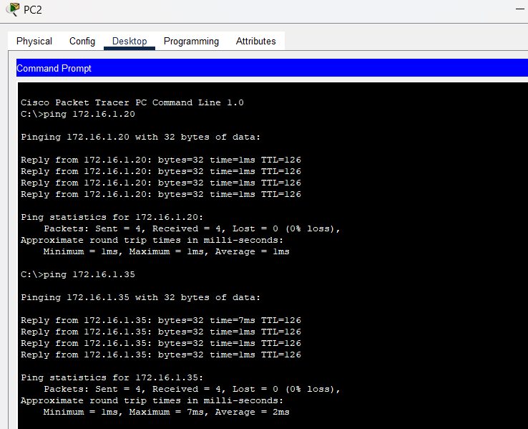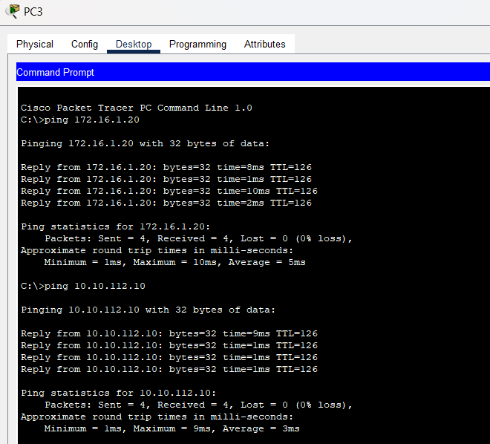

### **Q/A for the tasks:**

***(****There were many q/a sections inside the task pdfs. Copy the questions and your answers here.)*

**Task #02:**

**Step 1: Examine the current router IDs in the topology.**

Since no router IDs or loopback interfaces have been configured on the three routers, the router ID for each router is determined by the highest IP address of any active interface.

What is the router ID for R1?

Ans:192.168.10.5

What is the router ID for R2?

Ans: 192.168.10.9

What is the router ID for R3?

Ans:192.168.10.10

**Step 3: Reload the routers to force the new Router IDs to be used**.

When a new Router ID is configured, it will not be used until the OSPF process is restarted. Make sure that the current configuration is saved to NRAM, and then use the reload command to restart each of the routers.

When the router is reloaded, what is the router ID for R1?

Ans:10.1.1.1



When the router is reloaded, what is the router ID for R2?

Ans:10.2.2.2



When the router is reloaded, what is the router ID for R3?

Ans:10.3.3.3



### **Observation**:

**RIP:**

* **Simplicity:** RIP is easy to configure due to its simple hop count metric and minimal configuration parameters.
* **Convergence Speed:** RIP may exhibit slower convergence times in larger networks due to periodic updates and limited route information.
* **Scalability:** RIP may face scalability challenges in larger networks, as its maximum hop count is 15 and periodic updates can generate significant network traffic.
* **Ease of Implementation:** RIP is straightforward to implement, making it suitable for small to medium-sized networks with simpler topologies.

**OSPF:**

* **Complexity:** OSPF configuration is more complex compared to RIP, with detailed area design, network types, and various configuration options.
* **Convergence Speed:** OSPF typically offers faster convergence compared to RIP, thanks to its link-state database and Dijkstra's SPF algorithm.
* **Scalability:** OSPF is well-suited for larger networks due to its hierarchical design, support for variable subnetting, and reduced routing table sizes.
* **Resource Utilization:** OSPF minimizes network traffic by sending updates only when there are changes, enhancing network efficiency.

**Common Observations:**

* **Security:** OSPF supports authentication for routing updates, enhancing network security, while RIP lacks built-in security features.
* **Flexibility:** OSPF provides more flexibility in terms of summarization, allowing for efficient use of IP address space.
* **Route Summarization:** OSPF enables route summarization, leading to smaller routing tables and reduced overhead.
* **Compatibility:** Both RIP and OSPF may coexist in a network if needed, allowing for a phased migration strategy.

### **Challenges (if any):**

The OSPF task was harder because there was a lot of things to do. It was confusing to keep up with the instructions.